Sync OneDrive to a Personal Device
Issue/Environment/User Group
A Student, Faculty, or Staff member would like to link their USAHS OneDrive to their personal computer because they do not have access from their file explorer.
Cause
The USAHS OneDrive has not been synced to their computer.
Resolution
- The user will sign into https://portal.office.com.
- Click on the OneDrive icon on the left side of the web page.
- Once in the OneDrive, you will see a sync button near the top of the screen:
- Once selected, you will get a pop-up window to confirm you would like to sync your OneDrive to the current PC where you will select “Sync now”:
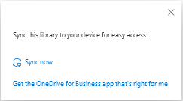
- Once synced, you will the “OneDrive – University of St. Augustine” in the Windows File Explorer 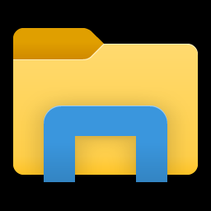 or Apple Finder 

