Setting Calendar Permissions within Outlook
Issue/Environment/User Group
A Student Faculty or Staff member would like to set up permissions for how visible their calendar is to others.
Cause
The user would like to either open or restrict visibility to their Outlook calendar for other users.
Resolution
- You will need to open the Outlook desktop application:
- Go to the Calendar section of Outlook by clicking the bottom left icon:
- Open the Folder tab:
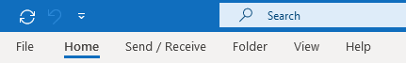
- Open Calendar Properties:
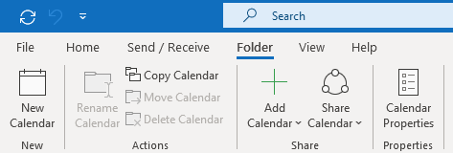
- Open the Permissions section:
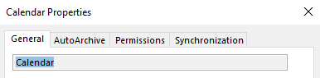
- This is where you will update your permissions. (1) If you select “My Organization” and (2) update its permissions below this will effect how others at the University (other individuals with @USA.edu emails) view your calendar. You can also (3) click “Add…” to create permissions for a specific user:
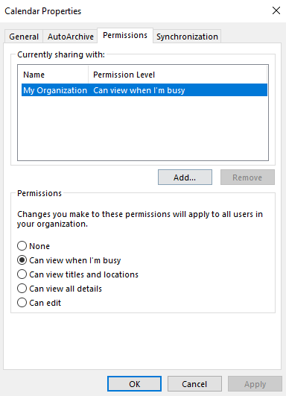
(3)
(2)
(1)
  - The permissions are as follows:
    - None – user will not be able to view anything on your calendar.
    - Can view when I’m busy – user will only be able to see when items are scheduled, but not any information about them.
    - Can view titles and locations – user will be able to view the title of the item and if there is a location associated with the item they will be able to see that too.
    - Can view all details – user will be able to open the items and see all information related to your calendar.
    - Can edit – they will be able to see all details in your calendar as well as add items and respond to items on your calendar for you.
- Click Apply to update the permissions changes.

