Granting Someone Permission to Schedule Meetings on Behalf of You
Issue/Environment/User Group
A Faculty or Staff member would like to assign access to another user to create RingCentral Meetings on behalf of them
Cause
The end user would like to have meetings create for them by another person with a RingCentral account
Resolution
Providing Access:
- Log into RingCentral online portal (service.ringcenral.com) using Single Sign-On
- Open the “Settings” tab, and then open the “User Details” drop-down.
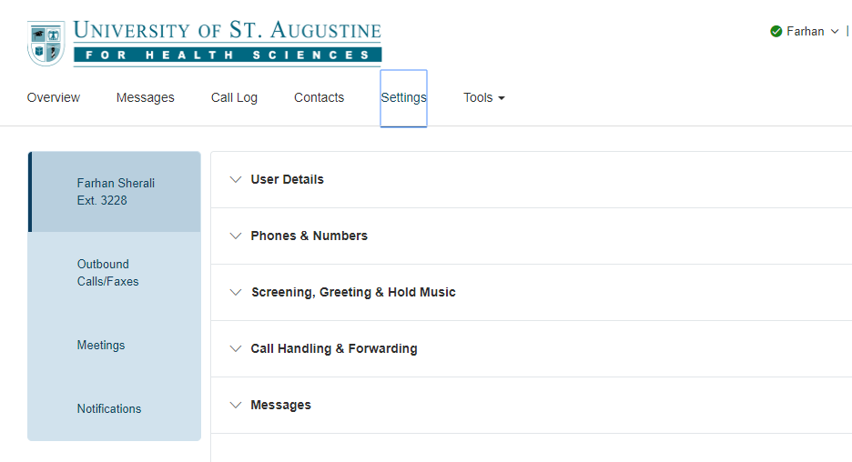
- Within the “User Details” drop-down select “Settings & Permissions”. Within this is “Schedule Meetings for Me”. Click “Edit” underneath to select who will be allowed the permission.
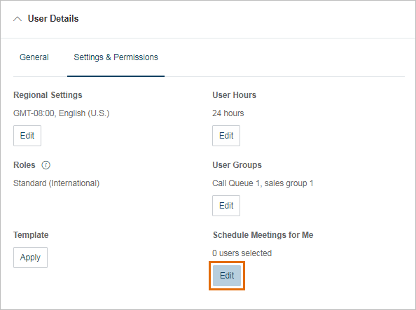
- You will select the individual who you would like to give permission to and then save the changes.
Schedule a Meeting on Behalf of Someone:
- Log into the RingCentral Meeting desktop application.
- Click the “Schedule” button.
- Click “Advanced Options” under “Meeting Options”
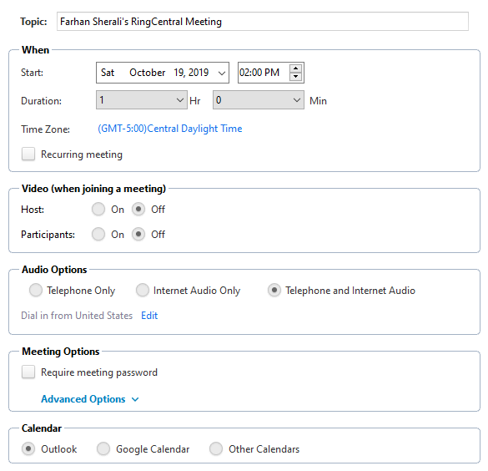
- “Meeting Options” will now have a sixth option to “Schedule for” which will allow you to choose the desired host for the meeting.
