Moving RingCentral Meeting Cloud Recordings to OneDrive
Issue/Environment/User Group
Unmanaged recordings can cause the RingCentral Cloud Storage to fill up and either not allow faculty and staff to be able to record to the cloud or require the removal of recordings that have not been backed up.
Cause
The RingCentral Cloud Storage space, where recordings are saved when “Record to the Cloud” is selected, has a set amount of storage space that can quickly fill up when many faculty and staff members are recording to the cloud but not managing their personal library.
Resolution
The best way to personally retain recordings and have them saved to the Cloud would be to download them from the RingCentral Cloud storage into the OneDrive:
- Log into the RingCentral online portal (https://service.ringcentral.com/) in Google Chrome. Using the Single Sign-on option will allow you to use your email and email password:
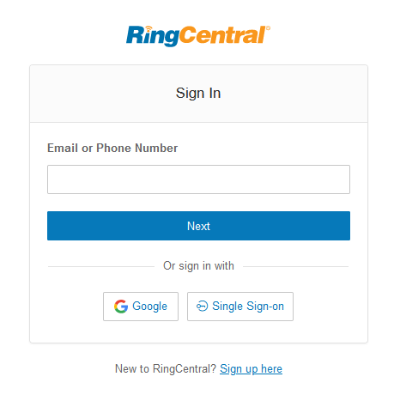

- From the top tool bar, select the “More” option:
- On the left side of the screen, select “Meetings” and then “My Recordings”:
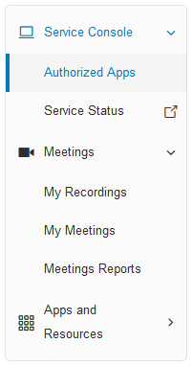

- Make sure you are on the “Cloud Recordings” page and select “Download” next to the Recordings you would like to move to OneDrive:
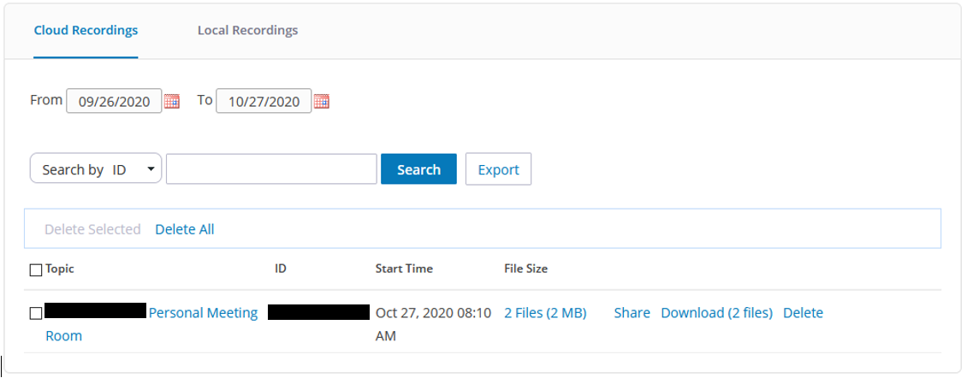

- The files that download (for each recording their will be one .mp4 (Video) and one .m4a (Audio only)) will need to be saved to OneDrive by selecting the arrow to the right of the download and then selecting “Show in folder” and dragging the files from the “Downloads” folder to the appropriate location in OneDrive:
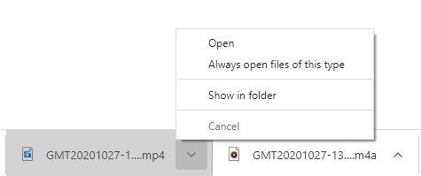

  - Once in OneDrive, you can easily create a link that can be shared on Blackboard with Students so that they can stream the lecture. This is convenient because Blackboard has a file size limit and most full lectures will not fit this. Please follow this link for more information: https://usa7417.zendesk.com/hc/en-us/articles/360056406754-Creating-a-Shareable-Link-from-OneDrive

