Creating a Shareable Link from OneDrive
Issue/Environment/User Group
A student, faculty, of staff member of the University would like to share digital content with others that can evolve with the updates made to their personal document.
Cause
The user would like to create an easily accessible, secure link that certain individuals can access to review a video, look through notes, update a presentation, etc. that will automatically update with changes made to the document.
Resolution
Using the OneDrive’s Share feature will allow you to share a file with others. They will be able to see changes you make to the document in real-time as well as be able to edit the document if given permission.
- Right click on the document you wish to share, and select “Share” with the OneDrive cloud next to it:
- First you will select the what types of people are able to view the link. By selecting the first box you will be brought to a page to update access:
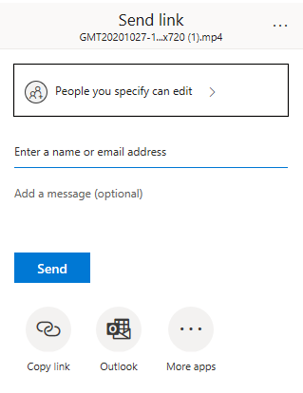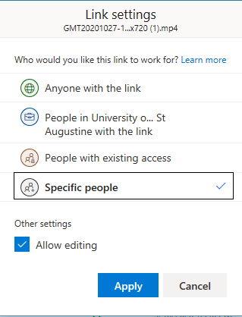
  - The first option is “Anyone with the link” which will make the link completely open and the link can be shared freely. This will have (1) an expiration that can be no later than 30 days after the creation of the link. You can also set a (2) password. You will also be able to (3) allow editing, or protect the document by unselecting the check box:
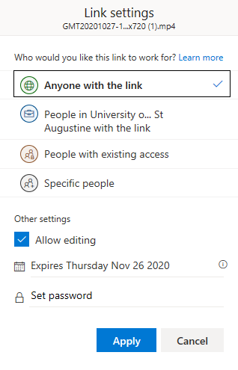
(3)

(2)

(1)

  - People in the University of St Augustine with the link is the next option. This allows anyone with an @USA.edu email to log in and view the content. This option will not have an expiration, but will also not have the set password feature. You can allow or revoke editing.
  - People with existing access is the next option. This option is used when users already have access to the document through another avenue such as it was previously shared with them, it is also saved in a Team or SharePoint they are a member of.
  - The last option is Specific people. This allows you to enter the email of the specific individuals you would like to share the document with. The University currently has restriction in place where sharing outside of the organization is blocked, so these emails would need to be @USA.edu emails.
- Once the type of people the link is accessible by, you will now decide how to share the content.
  - Specifically important for when sharing with specific people, but can be used with any option; you will be able to (1) enter individual emails and click (2) send to send an automated email allowing others access through the link:
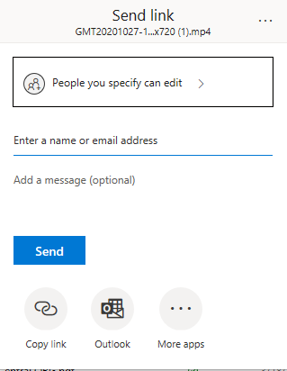
(2)

(1)

  - You can simply copy the link if there is a specific avenue you would like to share the content (Google Doc, personal email, text message, etc.):
  - Last, you can select “Outlook” to create a simple Outlook email that will already contain the link to the shared file:

You can also find more general information at this page from Microsoft: Sharing files, folders, and list items.

