Library Catalog Login Info
Issue/Environment/User Role
A Student or Faculty member would like to look through the Library Catalog.
Cause
The user would like to find research material in the Library Catalog, and needs to sign in to look through what material is available.
Resolution
- Open the myUSA portal (my.usa.edu) and select the Library tab:
- Move drop down to “Library Catalog, and use the search bar to the left to search your desired keyword for material in the Library Catalog:
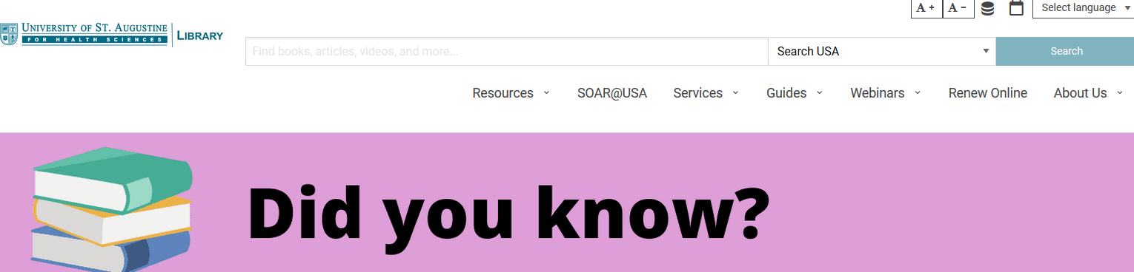
- You will only be required to sign in (using the first part of your email before “@usa.edu” and your email password) when requesting a loan from the library or adding yourself to the waitlist or extending your loan of an item:
