How to Forget a WiFi Network on Windows 10
Issue/Environment/User Role
A Student, Faculty, or Staff member is having trouble connecting to the WiFi on a Windows 10 PC.
Cause
A connectivity issue is preventing the user from successfully connecting to the WiFi.
Resolution
- Search “WiFi” in the search bar to the right of the Start Menu, and select “WiFi Settings”:
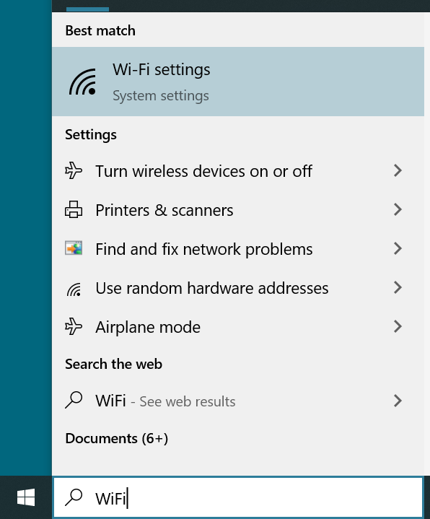
- Select “Manage known networks”:
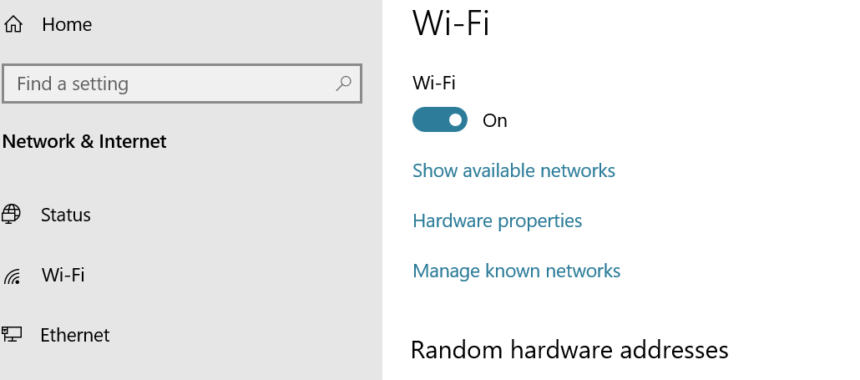
- Click on the network you would like to forget, and then click the “Forget” button:
