How to Access Blackboard
Issue/Environment/User Role
A Student or Faculty member does not know how to log into Blackboard.
Cause
User is new to the organization or has forgotten procedure over break.
Resolution
- Go to the myUSA portal (https://my.usa.edu).
- Open the Blackboard tab, and open the “Access Blackboard Learn Here” link:
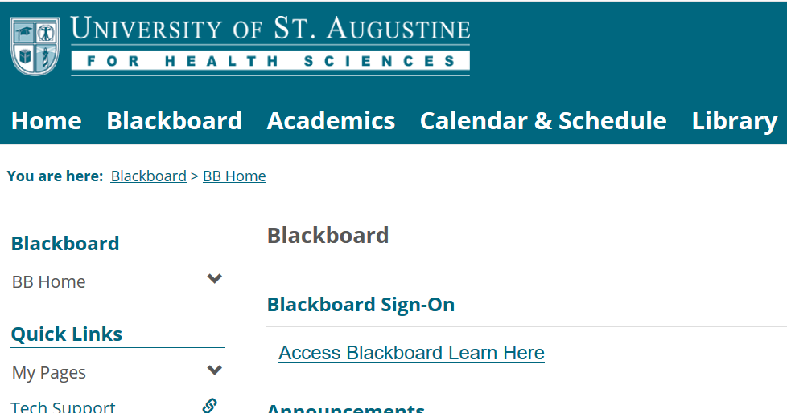
- Sign-in using your USA.edu email and email password:
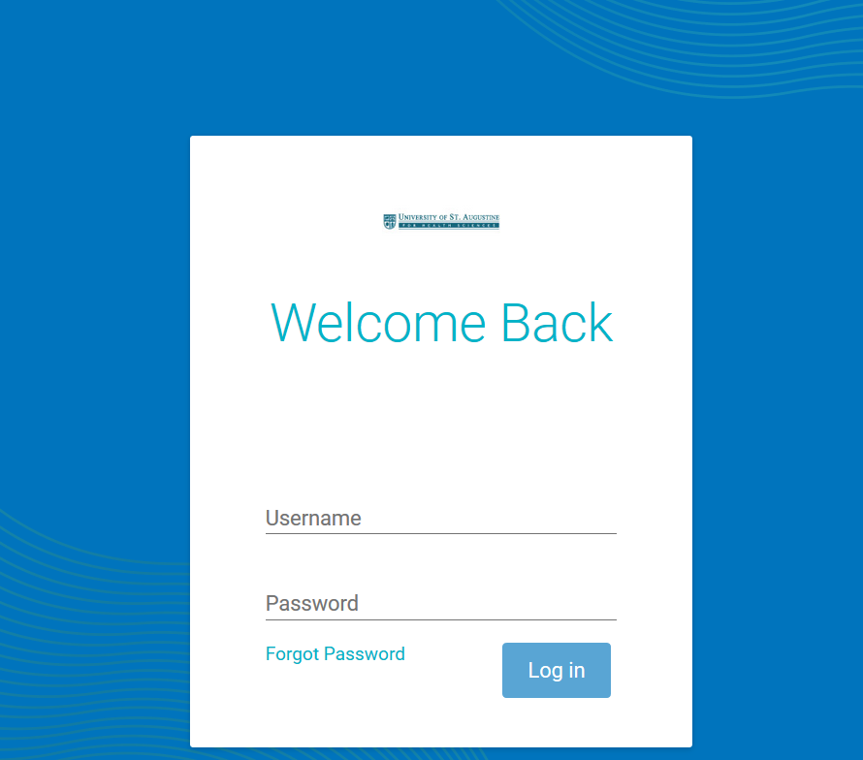
- You will next see the following load page, getting your Blackboard account ready:
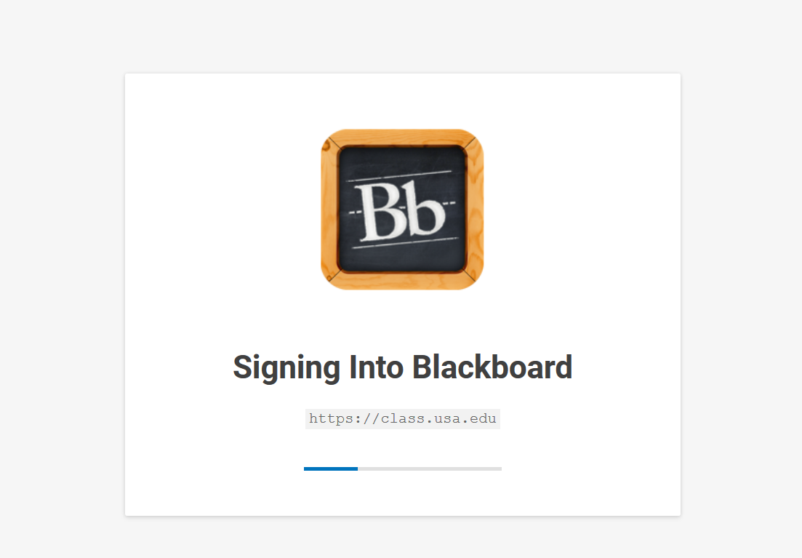
- You are now accessing Blackboard!

