Accessing Grammarly
Issue/Environment/User Group
A Student, Faculty, or Staff member would like to access a Premium Grammarly subscription through the University.
Cause
The user would like a more complete grammar and spell check feature across web browsers.
Resolution
- Log into the MyUSA Portal (https://my.usa.edu):
- Open the Student Services tab:
- Open the Writing Center section on the left side of the page:
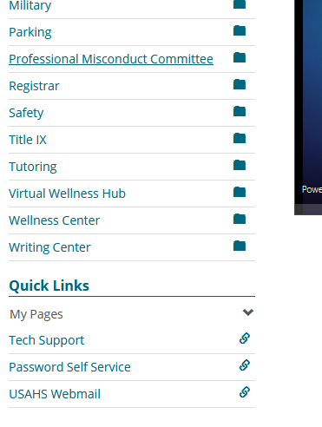
- Open the Online Resources section on the left side of the new page:
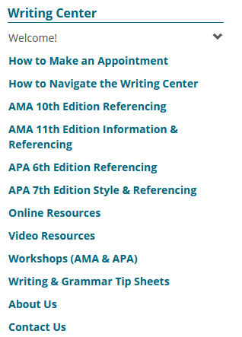
- Click the Grammarly link (the second section on the Online Resources page):
- You will be taken to this Grammarly page where you will enter your (1) Full Name, (2) your USA.edu email, and (3) a stand alone password for Grammarly:
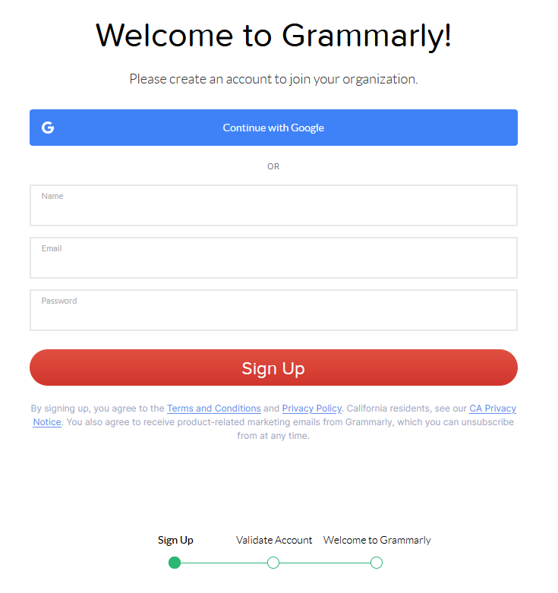
(3)
(2)
(1)
- You will be sent an email to your USA.edu email where you will click the Verify Email button which will lead you to a page welcoming you to Grammarly that will automatically download Grammarly to your default browser.
For you convenience, here is a direct link to sign up for Grammarly: https://www.grammarly.com/edu/signup
If you have already signed up for Grammarly not using the instructions above with your USA.edu email, you can find instructions here on how to convert that into a Premium subscription from a free subscription: https://support.grammarly.com/hc/en-us/articles/115000091691-I-signed-up-at-Grammarly-com-instead-of-Grammarly-com-edu-What-should-I-do-
If you have any other questions or concerns about Grammarly, please reach out to the Writing Center at WritingCenter@usa.edu

